quwsarohi@gmail.com Section: Recursion, Bitwise, Iteration and Greedy Page : 1

**// 8 Queen (Uva-11195)**

**// Backtracking with Bitmask**

//row, column, leftDiagonal, rightDiagonal

//placing queen in row major order

//we check if it is possible to place the queen in that row(of a fix column)

//if so, move forward

int cnt = 0, ALL = (1 << 5) – 1; // testing for n = 5 queens

void backtrack(int r, int c, int ld, int rd) {

if(r == ALL) { //ALL = n number of 1 in bitset (starting from least)

cnt++; //if all rows are taken

return; }

//pos = (those bits which we want to work with(to avoid overflow)) & (~(row where queen placed | if left diagonal attacked || if right diagonal attacked))

int pos = ALL & (~(r | ld | rd)); //negate the or, so the set bits are accessable

//there are also set bits, whose position is greater than n, so to turn them off, we used ALL with it (&)

while(pos) { //pos is the suitable places for placing queen, place queen in each position, and move forward

int place = pos & -pos; //get right most set bit

pos -= place; //turn off the right most set bit from place

if(mp[make_pair(place, 1 << c)]) //checking if the place can be used

continue;

//for each (left to right)column left diagonal moves left from the queens place(s), right diagonal moves right from the queens place(s)

backtrack(r | place, c+1, (ld | place) << 1, (rd | place) >> 1);

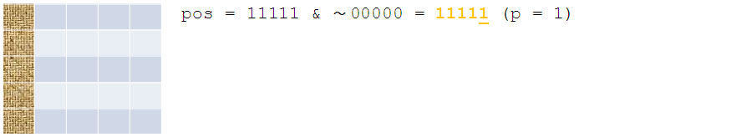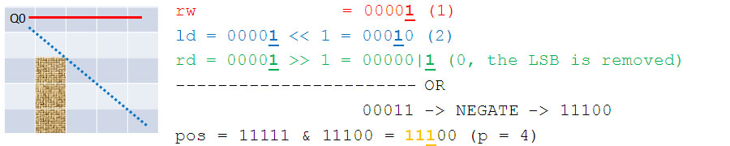**} }**

Fig : 8 Queens Simulation

**// Subset Sum**

**// Bitmask Trick**

**// Complexity : O(2^n)**

void SubsetSum(int val[], n) { // val[] contains element value, n is the length of val array

int maxVal = 0, bitPos;

for (i = 0; i < (1 << n); i++) { // The main routine, variable ‘i’ (the bitmask) has been declared earlier

int sum = 0, cnt; // For each subset, O(2^n)

for (int j = 0; j < n; j++) { // Check membership, O(n)

if (i & (1 << j)) // Test if bit ‘j’ is turned on in subset ‘i’?

sum += val[j], cnt++; // If yes, process ‘j’

}

quwsarohi@gmail.com Section: Recursion, Bitwise, Iteration and Greedy Page : 2

if(sum > maxVal) {

maxVal = sum;

bitPos = I; // The answer is found: bitmask ‘i’

} }

for(register int i = 0; i < l; i++) // Prints the taken values

if(pos & (1 << i))

printf("%d ", val[i]);

}

**// Iteration with Bitwise (Complete Search)**

**// Uva – 725 Division**

/*Abridged problem statement: Find and display all pairs of 5-digit numbers that collectively use the digits 0 through 9 once each, such that the first number divided by the second is equal to an integer N, where 2 ≤ N ≤ 79. That is, abcde / fghij = N, where each letter represents a different digit */

//Main part of code

for (int fghij = 1234; fghij <= 98765 / N; fghij++) {

int abcde = fghij * N; // This way, abcde and fghij are at most 5 digits

int tmp, used = (fghij < 10000); // If digit f=0, then we have to flag it as used

tmp = abcde;

while (tmp) {

used |= 1 << (tmp % 10); tmp /= 10; } // Marking all digits as used

tmp = fghij;

while (tmp) {

used |= 1 << (tmp % 10); tmp /= 10; } // Marking all digits as used

if (used == (1<<10) – 1) // If all digits are used (111111111)

printf("%0.5d / %0.5d = %d\n", abcde, fghij, N); // If all digits are used, print it

}

**// Iteration (Complete Search)**

**// Uva – 441 Lotto**

//Given 6 < k < 13 integers, enumerate all possible subsets of size 6 of these integers in sorted order. (12 C 6 = 924 outputs)

// Main chunk code

for (int i = 0; i < k; i++) // input: k sorted integers

scanf("%d", &S[i]);

for (int a = 0 ; a < k - 5; a++) // six nested loops!

for (int b = a + 1; b < k - 4; b++)

for (int c = b + 1; c < k - 3; c++)

for (int d = c + 1; d < k - 2; d++)

for (int e = d + 1; e < k - 1; e++)

for (int f = e + 1; f < k; f++)

printf("%d %d %d %d %d %d\n",S[a],S[b],S[c],S[d],S[e],S[f]);

**// Bisection Method**

**// Complexity : O(log 2 ((max − min) / e))** e : A small threshold 1e-9

void bisection() {

double lo = 0.0, hi = 10000.0, mid = 0.0, ans = 0.0;

for (int i = 0; i < 50; i++) { // Looping 50 times should be precise enough as log_2 ((10000.0 - 0.0) / 1e-9) ~= 43

quwsarohi@gmail.com Section: Recursion, Bitwise, Iteration and Greedy Page : 3

mid = (lo + hi) / 2.0; // Try the middle value

if (can(mid)) { // ‘can’ function is a simulator that tests if this mid value can be the answer

ans = mid; // Save the value, then continue

hi = mid; } // Note : This version of code gives floating values this can also be modified to find integer value as well

else // if (lo + hi) & 1== 1 {mid1 = (lo+hi+1)/2, mid2 = (lo+hi-1)/2;} |use the best option according to problem

lo = mid; // else mid1 = (lo+hi)/2;

}

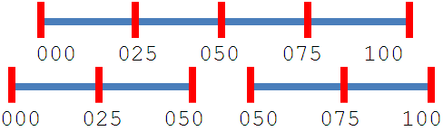**// Recursive and Dynamic Programming**

**// Uva 10003 Cutting Sticks**

/*Given a stick of length 1 ≤ l ≤ 1000 and 1 ≤ n ≤ 50 cuts to

be made to the stick (the cut coordinates, lying in the range [0..l], are given). The cost

of a cut is determined by the length of the stick to be cut. Your task is to find a cutting

sequence so that the overall cost is minimized. */ Fig: Cutting Sticks Illustration (optimal 200)

int l, n, A[55], memo[55][55];

int cut(int left, int right) {

if (left + 1 == right) // If left + 1 == right, there is no space to cut!

return 0;

if (memo[left][right] != -1) // Memorization

return memo[left][right];

int ans = 2000000000; // An INF value

for (int i = left + 1; i < right; i++)

ans = min(ans, cut(left, i) + cut(i, right) + (A[right]-A[left]));

return memo[left][right] = ans;

}